With all days of the week. ## With Glucose Target (80 - 130) ## Total days calculated: 7

Target Chart | Date | % in Target | % in Low | % in High | # of Readings | Min | Mean | Max | Std. Dev. | 25% | Median | 75% | IQR | Est. Std. Dev. | SE Mean | %CV
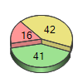 | Sun, 15.11.2015 | 41 % | 16 % | 42 % | 274 | 45 | 138 | 254 | 59 | 89 | 118 | 196 | 107 | 79 | 4 | 43 %
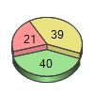 | Sat, 14.11.2015 | 40 % | 21 % | 39 % | 256 | 47 | 126 | 217 | 52 | 85 | 109 | 185 | 100 | 74 | 3 | 41 %
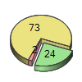 | Fri, 13.11.2015 | 24 % | 2 % | 73 % | 288 | 69 | 160 | 247 | 44 | 126 | 162 | 196 | 69 | 51 | 3 | 28 %
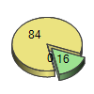 | Thu, 12.11.2015 | 16 % | 0 % | 84 % | 286 | 85 | 179 | 259 | 41 | 151 | 182 | 201 | 50 | 37 | 2 | 23 %
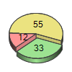 | Wed, 11.11.2015 | 33 % | 12 % | 55 % | 284 | 41 | 135 | 194 | 44 | 95 | 145 | 177 | 82 | 61 | 3 | 33 %
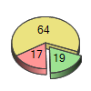 | Tue, 10.11.2015 | 19 % | 17 % | 64 % | 261 | 44 | 145 | 242 | 52 | 86 | 158 | 185 | 99 | 73 | 3 | 36 %
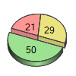 | Mon, 9.11.2015 | 50 % | 21 % | 29 % | 288 | Low | 112 | 206 | 42 | 86 | 107 | 137 | 52 | 38 | 2 | 37 %

